December 2023 Newsletter
Greetings Everyone!
We have ended 2023 on a great note, so many accomplishments for Family Promise and its families. There have been great achievements and growth. We look forward to seeing what this new year has in store for Family Promise. We have a few families that will be graduating from the program and have done amazing work and with the help and support of you all. We would like to show much gratitude to everyone for all the gifts that were donated to our families. One of the hardest situations during the holidays for some parents facing financial hardships is not knowing if they will be able to provide gifts. Organizations within the community were able to put these parents’ minds at ease and tell them this would be the least of their problems, we have a generous community, and they would be able to enjoy the holidays without having any burdens. Special thanks to American Legion, Church of Latter-Day Saints, Legacy Elite Athletics, First Christian, Optimus Physical Therapy and Sherry Wallace you truly brought the Christmas spirit to the families here at Family Promise.

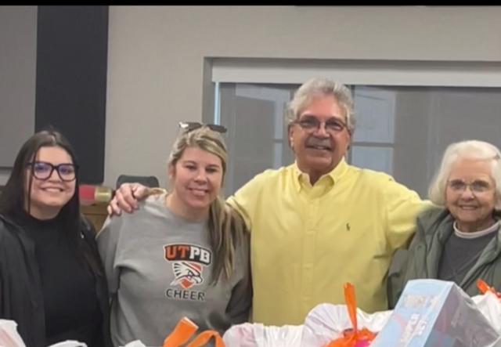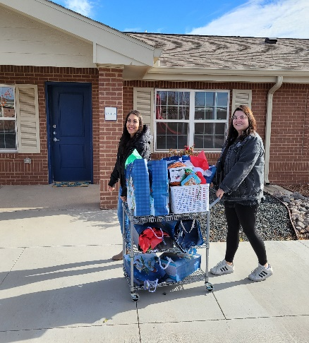

Counselor’s Corner

Happy Holidays!

Happy New Year!
Hello families!
The Counseling Corner at Family Promise of Midland Texas DECEMBER 2023
As we approach the holiday season, it is important to remember that it is very common to feel added stress — and this stress can worsen symptoms of a mental health condition, such as depression or anxiety, or a substance use disorder. Many times, we feel this way because we miss people in our lives that are now gone, or we just feel the weight of the world while trying to rebuild our current lives.
However, there are ways to help address stress or condition and improve your mental health. Below are strategies to help you find moments of joy amidst the hustle and bustle of this holiday season.
In this newsletter I decided to create ways to combat these feelings by giving some helpful strategies that have been proven to work with some people facing this issue.
To request a copy of strategies please email address below. (For online letter)
Warmest regards,
Crystal Featherstone, M.S., LPC-A
cfeatherstone@familypromiseofmidland.com
432-218-8231 EXT: 715 TEXT: 432-269-1933

Families from Family Promise
Norma is one of our moms here at Family Promise. We could not be prouder of the huge accomplishments she has made and working hard to purchase her own home for her family.
From day one Norma has been diligent and dedicated to her goals.

Norma's Statement,

I thank God for blessing me and my family with this program. Before coming into the program, I found myself in a very difficult situation in my life, and since I came into Family Promise things started changing for the better.
Family Promise has helped me reach goals, it has educated me financially, and more. Family Promise listens to my struggles and helps me if I ever have a hard time with my teenagers, they help us psychologically and personally, I have never been able to save money before, and my dream of ever buying a house was unreachable to me. Family Promise has helped me, and my family move towards that dream. May God continue to bless the program and the staff that help families. They want the best for us.

Help us spread the word!!!
Join us for a night of fun!
For added information you may contact me at 432-218-8231

Family Accomplishments
A parent has gained his driver’s license.
One of our teenagers now has a saving of a total of $8,600

This Photo by Unknown Author is licensed under CC BY-NC-ND

If you would like to donate here are some items that are currently needed:
Diapers size 3,5 and 6
Wipes
Hygiene products
Scarves, gloves, and beanies.
Here is a link for free covid test if you can spare one or two that would be helpful!
https://special.usps.com/testkits

Family Count
MIHN
Traylor Family 24F, 2F. 7mos F
Gallegos Family 7F, 4F, 3M, 5mos M
Cordero Family 28F, 3F
Mincey Family 37F, 15F, 13M, 10M

Families Forward
Moody Family 23M, 25F, 2M
Davis Family 24F, 28M, 3F, Infant M
Viera Family 36F, 21M, 17M, 11M, 1M, 6mos M
Molina Family 24F, 6M, 2F, 1F, 7mos M
Molina Family 25F, 2M, 1mos F
Baker Family 40F, 7M, 7M
Carrico Family 28F, 8F, 4F

