November 2023 Newsletter
Greetings Everyone!
We hope everyone had a fantastic Thanksgiving! Family Promise had so much to be grateful for. I know I mention it often and will always do so, but we are especially grateful for our community and all who contributed. We could not achieve this success without you.
Dell Bowie and the Pioneers for years has furnished boxes of Thanksgiving items for families to make a complete thanksgiving meal including a turkey and all the side dishes. It’s amazing how Dell and the pioneers have provided these boxes every year. Thank you for making thanksgiving special every year for the families.
HEB has continued to provide our families with food when the help is needed. HEB contributed to numerous families in tough times and made it one last burden they needed to endure.
We are forever grateful to you all!
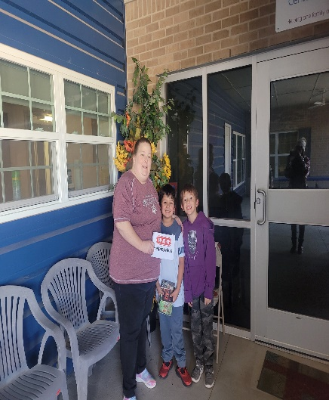

The Counseling Corner Presents…

Money Belief’s & Behaviors Assessment
Money is a charged topic for many. Some feel guilt or shame when they talk about money, while others view it as a source of conflict or disagreement. As a result, it’s common to avoid the subject altogether. But this means money’s impact on one’s life and relationships are never fully understood.
The Money Beliefs & Behaviors worksheet broaches this neglected subject in a non-threatening way, giving individuals and couples a chance to explore and reflect on their financial values, attitudes, and practices. Clients quickly get a sense of their views on money after indicating where they fall on 16 scales covering common financial beliefs and behaviors.
Use this worksheet for individuals or couples open to exploring their financial beliefs and behaviors. This could be in the context of a long-standing relationship, a couple contemplating moving in together, or an individual wanting to reflect on their money-related values, attitudes, and expectations. When using with couples, encourage them to discuss their answers in an open-minded, non-blaming way.

Take the time to complete this task with each other or by yourself. Thinking about how and why you handle your money in the manner you do can be a great help in fixing issues such as saving correctly, spending wisely, and becoming financially literate.
To request a copy of the work sheets please e-mail.
Happy savings!!!
Crystal Featherstone M.S., LPC-A

TREE FESTIVAL
The APS Advisory Board’s 1st Annual Festival of Trees was a fundraising event which brought awareness of the needs of vulnerable seniors and disabled adults in our region. Family Promise participated in this event, along with other organizations. Organizations furnished a decorated Christmas tree and guests made bids. The proceeds went to APS. We were lucky enough to have our Community Outreach Case Manager’s wife Yvette decorate a beautiful tree for Family Promise, both attended this special event.
The event took place downtown at the Bush Convention Center. Live music, heavy hors d’ oeuvres & drinks along with festivities were experienced during the raffle. Pictures below show our little winners for the Family Promise of Midland Christmas Tree.

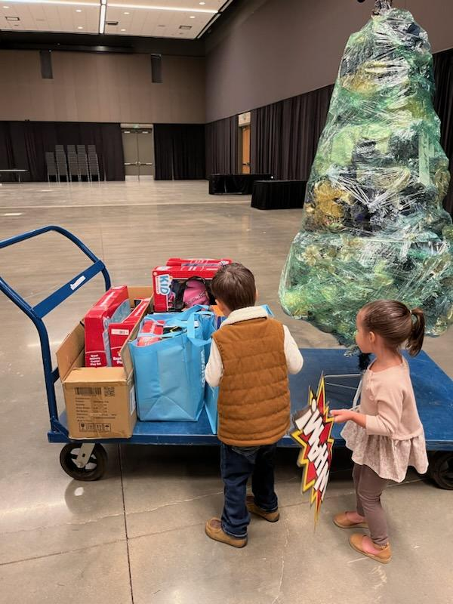

NEWS WORTHY

Here are a few things that we feel are New Worthy at Family Promise!
We have a newborn baby girl, this is the third baby born into Family Promise within this year, and one on the way!
We have a 7-year-old that is now reading on his own.
A teenager has received her driver's license.
We have a new family within Family Promise.
Martha Williams made an extraordinary donation of a vehicle that one of our families was in desperate need of.

We have two mothers who are doing excellent with their academics, and one has gained employment with a nonprofit.
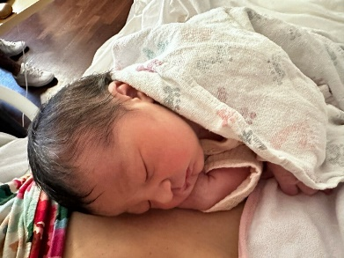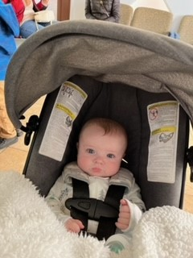
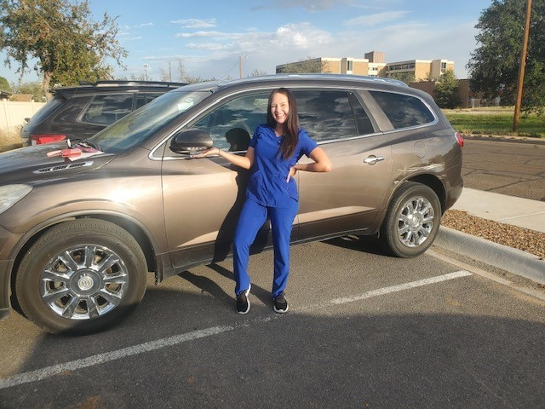

This Photo by Unknown Author is licensed under CC BY-NC-ND
If you would like to donate here are some items that are currently needed:
Diapers size 3,5 and 6
Wipes
Hygiene products
Scarves, gloves, and beanies.
Here is a link for free covid test if you can spare one or two that would be helpful!
https://special.usps.com/testkits

SAVE THE DATE!!

Family Count
MIHN
Traylor Family 24F, 2F. 7mos F
Gallegos Family 7F, 4F, 3M, 5mos M
Families Forward
Moody Family 23M, 25F, 2M
Davis Family 24F, 28M, 3F, Infant M
Viera Family 36F, 21M, 17M, 11M, 1M, 6mos M
Molina Family 24F, 6M, 2F, 1F, 7mos M
Molina Family 25F, 2M, 1mos F
Baker Family 40F, 7M, 7M
Carrico Family 28F, 8F, 4F
Young Family 28F, 1M, 3mosM
Hilburn Family 40F, 14F, 12F, 5F, 3F
Holden Family 34F, 40M, 17F, 14F, 12M, 10M, 9M, 8F, 6M, 4M
Duran Family 36M, 28F, 3M, 16F, 11M
Cortez-Valle Family 29F, 10F, 7M
Rodriguez Family 48F, 17F, 15F

This Photo by Unknown Author is licensed under CC BY

