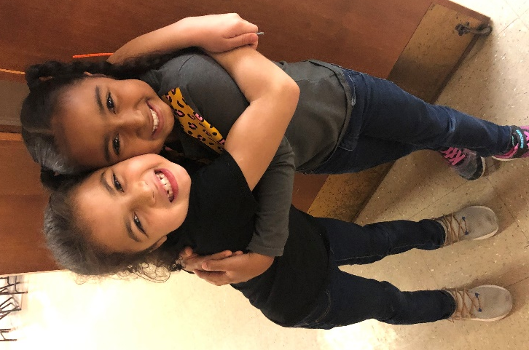
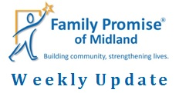
March 6, 2020
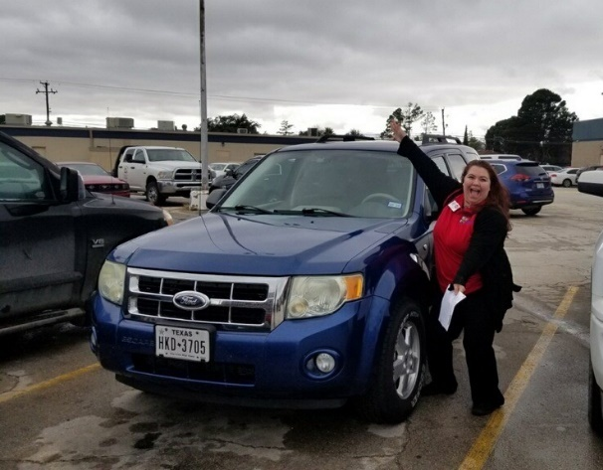
Congrats to MIHN mom, Jess, on receiving her first car! A HUGE thank you to the volunteer who donated it!
We have raised over $4.1 million for our Capital Campaign! Only $1.1 million to go! The foundations have strongly encouraged us to reach out to individual donors and our congregations to donate to the campaign as well. If you, your congregation, or someone you know might be interested in donating, please contact Tom Miller at tmiller@familypromiseofmidland.com. Together we can make our vision come true!
**Our Day Center on 2908 W. Ohio has moved to 2301 Haynes Dr, Unit B. As we begin the construction for our Capital Campaign, we are using a vacant Families Forward Duplexes as our Day Center temporarily. Additionally, our Day Center phone number, (432) 218-7630, is out of service during the construction. If you have any questions, please call us at (432) 688-7710. We are excited for the future changes!**

Construction has begun!!!

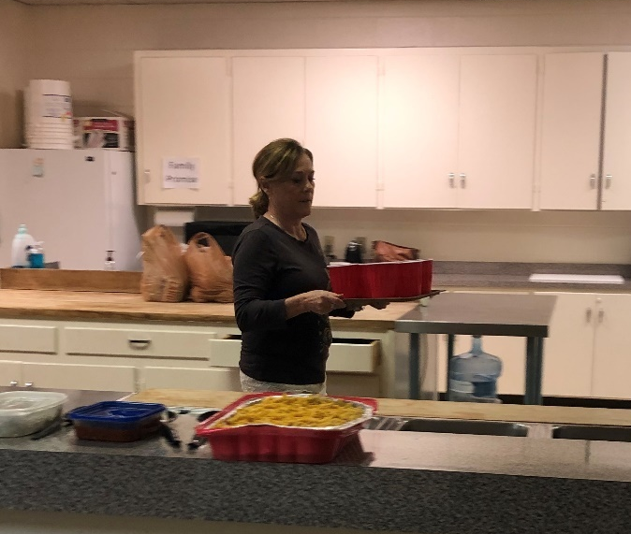
Hosting
We, currently, have two families in the MIHN; two adults and three children, ages 7, 6, and 2.
Family Promise of Midland thanks St. Mark’s United Methodist Church for hosting this past week. Special thanks to Volunteer Coordinators, Tina Mocksfield and April Bushman!
Thanks for all you do!
&
Have a joyful weekend!

