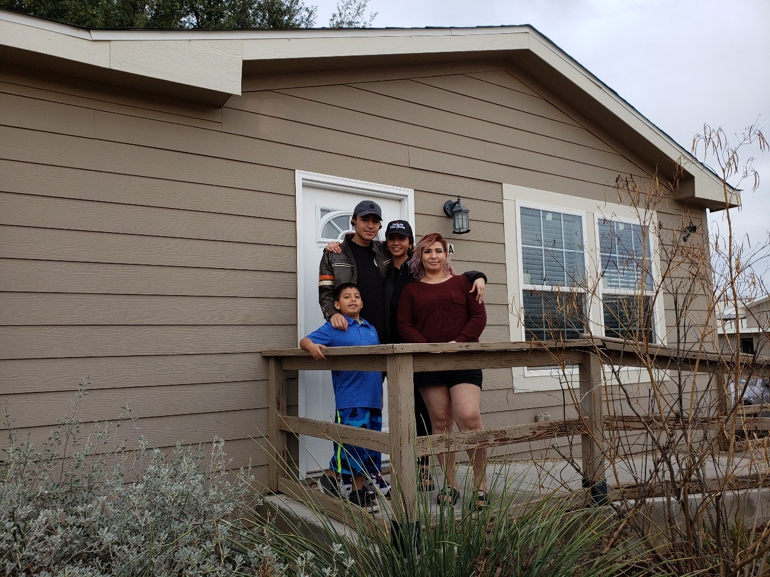
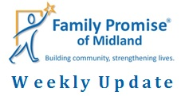
March 27, 2020
A HUGE thank you to H-E-B for granting Family Promise of Midland a $2,500 grant specifically for our families who have been impacted by the COVID-19 (Coronavirus) pandemic.
In the past week, 5 of our guests have been laid off due to the COVID-19 pandemic. Other guests are nervous they too may be laid off in the coming weeks. Please keep the families, and other vulnerable families in our community, in your prayers.
The MIHN will move to a static sight starting Sunday. This means that the families will spend the night at our Day Center instead of a host congregation. Hosting congregations will still bring nightly meals and provide groceries for the week. Our staff is working remotely, but you can still reach our staff by phone or email.
We have raised over $4.1 million for our Capital Campaign! Only $1.1 million to go! The foundations have strongly encouraged us to reach out to individual donors and our congregations to donate to the campaign as well. If you, your congregation, or someone you know might be interested in donating, please contact Tom Miller at tmiller@familypromiseofmidland.com. Together we can make our vision come true!
**Our Day Center on 2908 W. Ohio has moved to 2301 Haynes Dr, Unit B. As we begin the construction for our Capital Campaign, we are using a vacant Families Forward Duplexes as our Day Center temporarily. Additionally, our Day Center phone number, (432) 218-7630, is out of service during the construction. If you have any questions, please call us at (432) 688-7710. We are excited for the future changes!**

Hosting
We, currently, have two families in the MIHN; two adults and three children, ages 7, 7, and 2.
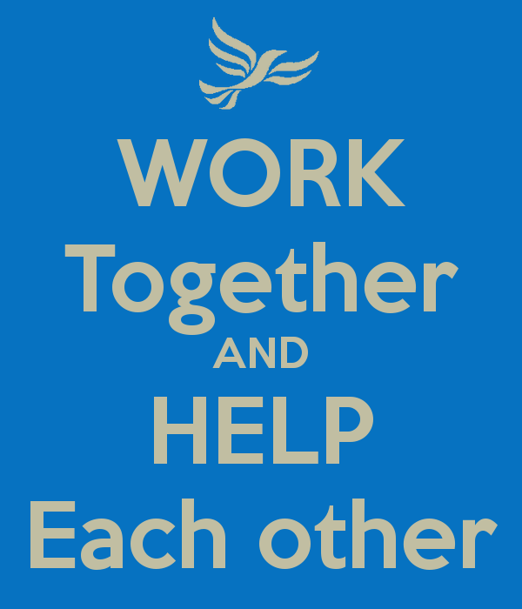
Family Promise of Midland thanks Goodwill Baptist Church for bringing meals this past week.
Special thanks to Volunteer Coordinator, Delisa Denmon!
Thanks for all you do!
&
Have a joyful weekend!

