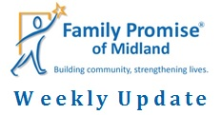
March 20, 2020
During this unsure time, please keep our families, and other vulnerable populations in your prayers. The MIHN will move to a static sight starting Sunday. This means that the families will spend the night at our Day Center instead of a host congregation. Hosting congregations will still bring nightly meals and provide groceries for the week. Our staff is working remotely, but you can still reach our staff by phone or email.
We brought a new family into the MIHN on Monday! Jeanne and her 3-year-old son and 10-month old daughter are excited for this opportunity!
We have raised over $4.1 million for our Capital Campaign! Only $1.1 million to go! The foundations have strongly encouraged us to reach out to individual donors and our congregations to donate to the campaign as well. If you, your congregation, or someone you know might be interested in donating, please contact Tom Miller at tmiller@familypromiseofmidland.com. Together we can make our vision come true!
**Our Day Center on 2908 W. Ohio has moved to 2301 Haynes Dr, Unit B. As we begin the construction for our Capital Campaign, we are using a vacant Families Forward Duplexes as our Day Center temporarily. Additionally, our Day Center phone number, (432) 218-7630, is out of service during the construction. If you have any questions, please call us at (432) 688-7710. We are excited for the future changes!**

Hosting
We, currently, have three families in the MIHN; three adults and five children, ages 7, 7, 3, 2, and a 10-month old.
Family Promise of Midland thanks True Lite Christian Fellowship for hosting this past week. Special thanks to Volunteer Coordinator, Priscilla Ceballos!
Thanks for all you do!
&
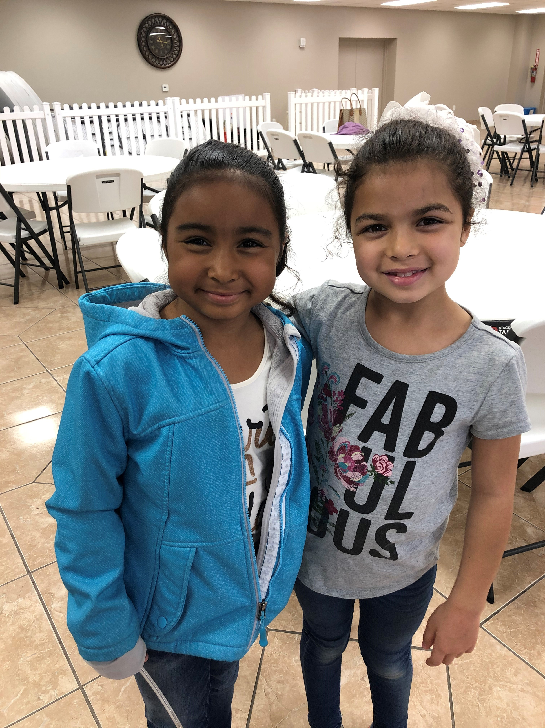
Have a joyful weekend!

