**May 18, 2022**



With the high temperatures, it’s safe to say Summertime is here! Time to get the sunscreen, flip-flops and jump into your nearest swimming pool! We have had a busy few months with a playground dedication in honor of Kirby Collier, our open house and just yesterday participating with Permian Basin Gives. We are looking forward to our annual Clay Shoot, I have attached a flyer and sign-up sheet as well. We want you to all know we appreciate all the support that has been shown to Family Promise of Midland. If you came and showed support or donated thank you for all you do!



We would like to acknowledge the individuals within Family Promise of Midland that are making progress to advance in their journey.

We have a teen when entering the program was failing is now passing all her classes, as well as numerous children that have entered our program have improved grades since entering Family Promise of Midland. I would also like to add that we have a straight “A” student!

We have a young Mother that is enrolled in Odessa College and will start her classes this week!

A mother of 3 just got word that she is now employed!

Mother of 2 finally got her driver’s license and will continue working to complete her GED!

Upon arrival we had mother of one that was very much destressed, hopeless, and depressed. Now her face exudes relief, confidence, and happiness.

All of this is possible because of your donations, time and prayers!

**Tuesday, May 17th we had the pleasure of being a part of Permian Basin Gives, along with numerous other non-profits. We are proud to report the final amount of donations in the amount of $1,868.65. The full amount that was donated to all the non-profit organizations was in the amount of $682,983.46 / Matching $44,694.28/ Number of donors 1,921. We want to thank all who made contributions on this day!**



[This Photo](https://www.flickr.com/photos/jeepersmedia/14023011317/) by Unknown Author is licensed under [CC BY](https://creativecommons.org/licenses/by/3.0/)

We are excited to share the results of the Target Circle Guest-Directed Giving program! This is so amazing how much we are supported by our community! You have all contributed to giving a hand up in changing the lives of those in need. Please see the results below!

Family Promise of Midland Texas Inc

$4,053.84 RECEIVED

New Eyes for the Needy

$3,866.80 RECEIVED

Wichita Falls Area Food Bank

$2,982.23 RECEIVED

Camp Fire North Texas

$2,314.34 RECEIVED

National Urban League

$1,782.79 RECEIVED

Wish List

Toys for girls and boys from toddlers to teens. We like to be able to give birthday gifts.

Baby wipes

Cleaning supplies – Fabuloso, Lysol Wipes, all and anything that consists of cleaning.

Last but not least is for a mother of 2, when this particular Mom first came to Family Promise of Midland, was very broken and hopeless. She did not even have support from her own family and could not get a head. Her story was the first story I heard starting my employment at Family Promise of Midland and let me tell you I do not get emotional easily and I was fighting back tears as she was telling her story. I am immensely proud of this mom. She has been dedicated to working the program diligently, even with such difficult obstacles as the death of her twin brother. She parents with love and patience, her youngest son is Autistic, she is constantly educating herself and his brother on Autism, she has thrived in taking care of her mentality among other things. Finally, she has recently earned her driver’s license, she is now ready for the road, but will have to put that aside till she is able to find a vehicle. IF by chance you or know anyone that you know has a vehicle that you would like to donate to this terrific Mom, please let us know.

Smiling Faces of Family Promise of Midland!

Families At Family Promise of Midland

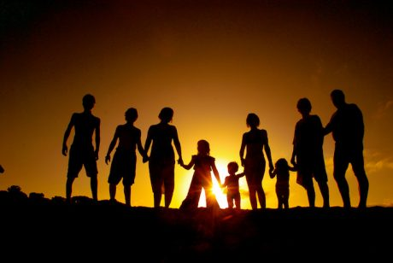

MIHN

Rendon Family 23F, 4F, 3F

Young Family 27F, 5mos M

Delgado Family 43F, 9F

Evans Family 39F, 13F

FF

Duplechin Family 46F, 16M, 15M Waiting List

Wilson Family 35F, 16F, 7F, 5F Single Mother of 6

Carrico Family 27F, 6F, 2F Single Mother of 6

Soto Family 33F, 4M, 1F Single Mother of 1

Adams Family 38F, 11F Single Mother of 1

Perez Family 38F, 10M, 6M

Beltran Family 28F, 9M, 5M,

Leonard Family 45F, 16M, 13M

Rico Family 29F, 4F, 3F, 1F

Yell Family 46F, 14F, 11M

Barrera Family 31F, 16M, 11M, 8F, 1M